SIMATS ENGINEERING (SAVEETHA SCHOOL OF ENGINEERING)
Department of Computer Science and Engineering
CO4 ASSESSMENT TOOL 2 – CI/CD Pipeline Design Exercise

Course Code: | CSA1008 | Course Title: | Software Engineering
CO Assessed: | CO4 | Assessment: | Assessment Tool 2 – CI/CD Pipeline Design Exercise
Weightage: | 20% | Total Marks: | 25
CO4 Statement: | Implement robust testing, quality assurance, and DevOps practices, emphasizing security, reliability, and ethics
Student Name: | ARTHI A | Reg. No.: | 192525152
Date: | 05.09.2026 | Duration: | 60 minutes

Code of Conduct
I ARTHI A (Name / Reg No) certify that this submission is my original work and that I have adhered to the guidelines specified for this assessment. I understand that any violation of academic integrity rules will result in disciplinary action.
Signature of the Student: _________________________
Annexure A – CI/CD Pipeline Design Exercise
Instructions to Students:
Each student is assigned an individual problem statement. Based on the assigned problem statement, design a CI/CD (Continuous Integration and Continuous Deployment) pipeline for the proposed software system to automate the processes of code integration, building, testing, and deployment.
The exercise should include:
- Analyze the project requirements and identify the CI/CD needs of the assigned problem statement.
- Design the CI/CD pipeline workflow showing stages such as source code management, build, testing, code quality analysis, packaging, and deployment.
- Identify suitable tools and technologies for each stage of the pipeline and justify their selection.
- Define appropriate automated testing strategies to be integrated into the pipeline.
- Design the deployment strategy, including development, testing/staging, and production environments.
- Incorporate appropriate security, quality checks, notifications, and rollback mechanisms in the pipeline.
- Prepare a CI/CD pipeline diagram and explain the workflow from code commit to deployment.
Deliverable: Submit a CI/CD Pipeline Design document containing the pipeline architecture/diagram, stages, tools, configuration/workflow, testing strategy, deployment process, and justification based on the assigned problem statement.
1. Requirement and Pipeline Analysis
Project Context
The Smart Construction Project Management System (SCPMS) backend is a containerized Node.js/Express service backed by PostgreSQL, currently version-controlled on GitHub with a main/develop/feature branching strategy. The system's core value proposition — replacing manual, delay-prone reporting with near-real-time data — depends directly on how quickly and reliably code changes reach a running environment. A manual, ad-hoc deployment process (build locally, copy files to a server, restart manually) would reintroduce exactly the kind of slow, error-prone, undocumented process this project is meant to eliminate in the construction domain itself.
CI/CD Needs Identified
- Every push and pull request must be automatically built and tested, so a broken change is caught before merging into develop or main, not discovered manually later
- The existing Dockerfile and docker-compose.yml must be exercised automatically in CI, not just locally, so the containerized environment itself is continuously validated
- Database-dependent code (the requisitionRepository.js layer) requires a real database available during automated testing, not just mocks, given the real defects (missing env vars, lost data on container removal) already found through manual testing
- Given the system's role in approval and payment workflows, deployments must be gated by both automated checks and a manual approval step before reaching production — consistent with NFR-4 (authenticated, auditable actions) already defined for the application itself
- A rollback mechanism is required given NFR-5's 99.5% uptime target — a bad production deployment must be reversible quickly, not require manual investigation under pressure
Requirements Traceability
Application Requirement | CI/CD Implication
NFR-5 — 99.5% uptime | Automated smoke tests post-deployment, plus a fast, scripted rollback path
NFR-6 — Scalability | Pipeline builds a stateless, horizontally-scalable container image, not a server-specific manual install
NFR-7 — Maintainability | Every layer (controller/service/repository) is independently unit-testable, enabling fast, isolated CI test stages
Existing Git branching strategy | Pipeline triggers differ by branch: feature branches run build+test only; main triggers full build, test, package, and deploy
2. Pipeline Architecture and Workflow
The pipeline below extends the GitHub Actions workflow already sketched in the project's Git & Docker report, formalizing it into seven ordered stages.
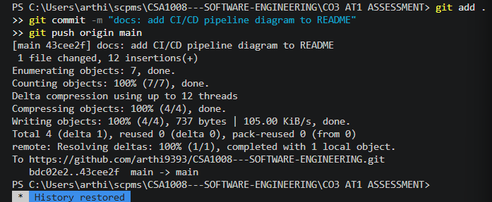
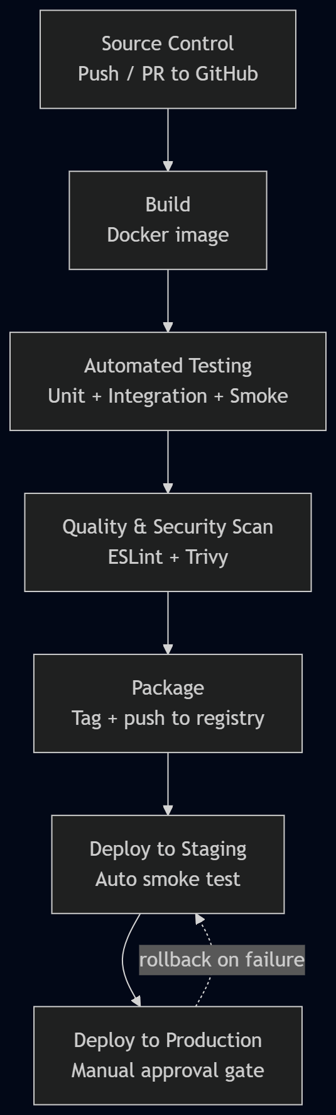
Stage-by-Stage Workflow
Stage | Trigger / Input | Purpose
1. Source Control | git push or pull request to GitHub (feature/*, develop, main) | Establishes the single source of truth and triggers the pipeline automatically — no manual pipeline start
2. Build | Successful checkout of the triggering commit | Builds the backend Docker image via docker build -f Dockerfile, using the same Dockerfile that runs locally, guaranteeing environment parity
3.Automated Testing | Successful build | Runs unit tests (service/repository layers) and integration tests (full docker compose stack including PostgreSQL) inside the CI runner
4. Code Quality and Security Scan | Tests passed | Runs static analysis (ESLint) and container image vulnerability scanning (Trivy) before the image is considered releasable
5. Package | Quality gate passed | Tags the image with the Git commit SHA and pushes it to a container registry (GitHub Container Registry), making it an immutable, addressable artifact
6.Deploy to Staging | Successful package (any branch merging to develop or main) | Deploys the packaged image to a staging environment and runs automated smoke tests (e.g., GET /requisitions returns 200)
7.Deploy to Production | Staging smoke tests pass AND manual approval (main branch only) | Deploys the same, already-tested image to production — never a separately built artifact, eliminating "it worked in staging but not prod" drift
Branch-to-Stage Mapping
- feature/* branches: Stages 1–4 only (build, test, quality) — fast feedback for a developer without deploying anything
- develop branch: Stages 1–6 — full pipeline through staging deployment, allowing integration testing in a real environment before release
- main branch: Stages 1–7 — the only branch permitted to reach production, and only after the manual approval gate in Stage 7
3. Tools and Technology Selection
Stage | Tool | Justification
Source Control | GitHub | Already in use for this project; native integration with GitHub Actions avoids introducing a second platform
CI/CD Orchestration | GitHub Actions | No separate CI server to host or maintain; workflow-as-code (.github/workflows/ci.yml) lives alongside the source it builds, and a starter workflow already exists from the Git & Docker assignment
Build | Docker (docker build) | The application is already containerized; using the same Dockerfile in CI as in local development guarantees the image behaves identically everywhere
Unit/Integration Testing | Jest | Standard, widely-supported Node.js test framework; integrates cleanly with GitHub Actions via a simple npm test step and produces machine-readable results for the pipeline to act on
Static Code Analysis | ESLint | Directly addresses a gap already identified in the project's Code Review report (no linting configured yet); catches style and correctness issues before human review
Security Scanning | Trivy | Free, open-source, purpose-built for scanning container images for known vulnerabilities (CVEs) in OS packages and dependencies — a natural fit given the project already produces Docker images
Container Registry | GitHub Container Registry (ghcr.io) | Same authentication and permissions model as the existing GitHub repository, avoiding a third-party account/credential to manage
Deployment Target | Docker Compose (staging), with a documented path to Kubernetes/Swarm (production, future) | Consistent with the project's current Architecture Design report, which already identifies container orchestration as a future scaling step rather than an immediate requirement
Notifications | GitHub Actions built-in status checks + Slack webhook | Surfaces pipeline failures directly where the team already works (PR view, Slack), without requiring a dedicated monitoring dashboard at this project's current scale
4. Automated Testing Strategy
Testing Layers Integrated Into the Pipeline
Test Type | Scope | Pipeline Stage
Unit tests | requisitionService.js business logic in isolation (mocked repository) | Stage 3, runs first — fastest feedback, no external dependencies
Integration tests | requisitionRepository.js against a real, ephemeral PostgreSQL container spun up via docker compose in the CI runner | Stage 3, runs after unit tests — validates the actual database interaction, directly covering the failure modes found during manual testing (TC-12 through TC-16 in the project's Test Case Design document)
Container smoke test | docker compose up, then curl the /requisitions endpoint inside the CI job | Stage 3, final check before quality scanning — proves the packaged container actually serves traffic, not just that unit tests pass
Post-deployment smoke test | Automated HTTP check against the live staging URL | Stage 6 — confirms the deployed environment (not just the CI runner) is healthy before promotion is even offered

Example CI Test Step
- name: Run unit and integration tests
run: |
cp .env.example .env
docker compose up -d db
npm install
npm test
docker compose down
Quality Gate Policy
A pull request cannot be merged into develop or main unless all automated tests pass and the ESLint/Trivy scan reports no high-or-critical findings — enforced via GitHub branch protection rules referencing the CI workflow's required status checks, not merely as a suggestion reviewers can override.
5. Deployment Strategy
Environments
Environment | Purpose | Deployment Trigger
Development | Local docker compose up on a developer's machine; matches the setup already documented in the Git & Docker report | Manual, on-demand — not part of the automated pipeline
Staging | A persistent, shared environment running the same Docker image that would go to production, used for integration testing and manual QA before release | Automatic, on every successful merge to develop or main
Production | The live environment used by actual Site Engineers, Project Managers, Procurement, and Clients | Automatic build and test, but deployment itself gated behind a manual approval step (GitHub Actions environment protection rule)
Deployment Method
Deployments use the same immutable image built once in Stage 5 and promoted unchanged through staging and production — never rebuilt per environment. This directly follows from the packaging stage tagging images by Git commit SHA, so the artifact deployed to production is provably identical to the one already validated in staging.

6. Security, Quality Checks, Notifications, and Rollback
Security Practices
- Trivy scans every built image for known vulnerabilities before it is allowed to be pushed to the registry (Stage 4)
- Secrets (database passwords, registry credentials) are stored as GitHub Actions encrypted secrets, never committed to docker-compose.yml or the repository, consistent with the .env / .env.example separation already established in the project
- Production deployment requires a named GitHub Actions "environment" with required reviewers, directly implementing the authenticated, auditable-action principle already specified in NFR-4 for the application layer, now applied to the deployment process itself
Quality Checks
- ESLint enforces the coding standards already identified as missing in the Code Review report, applied automatically rather than relying on manual review
- Required status checks (tests, lint, scan) block merging directly in GitHub, rather than being an optional CI badge someone could ignore
Notifications
- GitHub Actions natively reports pass/fail status on every pull request and commit
- A Slack webhook step posts a message on pipeline failure at any stage, and on every successful production deployment, so the team has both failure alerts and a deployment audit trail in one channel
Rollback Mechanism
Because every deployed image is tagged with an immutable Git commit SHA, rollback is a redeploy of the previous known-good tag rather than a manual code revert and rebuild:
# Rollback example: redeploy the previous production image
docker pull ghcr.io/arthi9393/scpms-backend:<previous-sha>
docker compose -f docker-compose.prod.yml up -d
This mirrors the recovery approach already used manually during development — when the database persistence defect (TC-16) was found, the fix was validated with docker compose down/up before being trusted, the same pattern automated here for production incidents.
7. Pipeline Diagram and Workflow Explanation
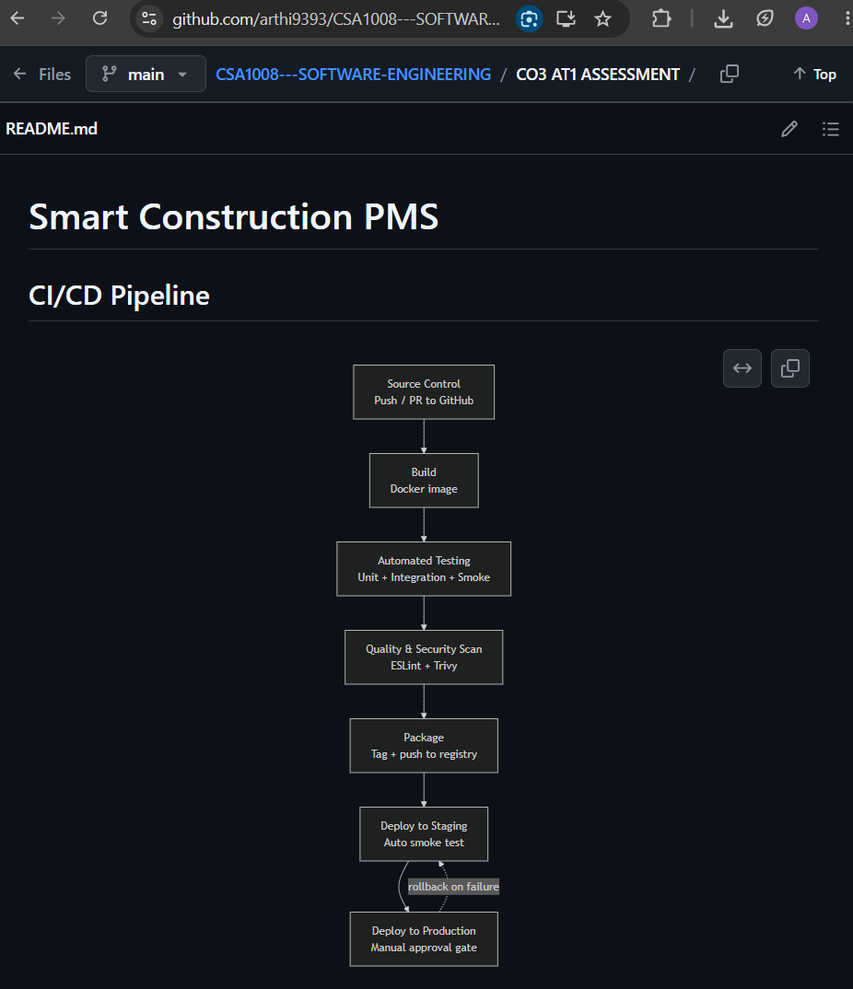
Workflow Explanation: Commit to Deployment
1. A developer pushes a commit to a feature branch or opens a pull request into develop
2. GitHub Actions automatically triggers the pipeline, building the Docker image using the project's existing Dockerfile
3. Unit tests run against the service layer, followed by integration tests against a real, ephemeral PostgreSQL instance, followed by a container-level smoke test — mirroring the same manual verification steps (TC-12–TC-16) already performed by hand during development, now automated
4. ESLint and Trivy scan the code and image respectively; any high-severity finding fails the pipeline before the image is ever packaged
5. On success, the image is tagged with the commit SHA and pushed to the container registry
6. On merges to develop or main, the same image is automatically deployed to staging and smoke-tested live
7. On main only, after staging passes, a designated reviewer manually approves production deployment; the identical, already-tested image is then deployed to production
8. If a post-deployment check fails or an incident is reported, the previous tagged image is redeployed via the documented rollback procedure, restoring service without requiring an emergency code fix under pressure
This workflow directly closes the gap between the project's existing manual testing practice (documented in the Test Case Design document) and a repeatable, automated process — every check that was previously run by hand against the live container (database connectivity, environment variable correctness, data persistence) has a corresponding automated stage here, so the same defects would be caught by the pipeline itself on the next occurrence rather than requiring manual discovery.

Rubrics for Calculation
Evaluation Criteria | Excellent (4 Marks) | Good (3 Marks) | Satisfactory (2 Marks) | Needs Improvement (1 Mark)
Requirement & Pipeline Analysis(15%) | Clearly analyzes the assigned problem and identifies comprehensive CI/CD requirements | Identifies most relevant requirements | Identifies basic requirements with some gaps | Requirements are unclear or incomplete
Pipeline Architecture & Workflow(25%) | Designs a complete, logical pipeline covering source, build, test, quality check, package, and deployment stages | Pipeline covers most major stages with minor gaps | Basic pipeline is designed but several stages are missing | Pipeline is incomplete or poorly structured
Tools & Technology Selection(20%) | Selects appropriate tools for each stage and provides clear justification | Appropriate tools selected with reasonable justification | Tools are identified but justification is limited | Tools are inappropriate or not clearly identified
Automated Testing & Quality Integration(15%) | Effectively integrates automated testing and code-quality/security checks into the pipeline | Includes major testing and quality checks | Includes basic testing with limited integration | Testing/quality checks are missing or inappropriate
Deployment, Security & Rollback Strategy(15%) | Clearly designs deployment environments, security practices, monitoring, and rollback strategy | Covers deployment and most security/rollback aspects | Basic deployment strategy with limited security/rollback details | Deployment strategy is incomplete or lacks security considerations
Pipeline Diagram & Documentation(10%) | Clear, accurate, professional diagram with excellent explanation and documentation | Well-presented diagram and documentation with minor issues | Adequate diagram/documentation but lacks clarity | Poorly presented, incomplete, or difficult to understand
Criteria | Mark
Requirement & Pipeline Analysis(15%) | /5
Pipeline Architecture & Workflow(25%) | /4
Tools & Technology Selection(20%) | /4
Automated Testing & Quality Integration(15%) | /4
Deployment, Security & Rollback Strategy(15%) | /4
Pipeline Diagram & Documentation(10%) | /4
TOTAL | /25

